**GUJARAT TECHNOLOGICAL UNIVERSITY**

Chandkheda, Ahmedabad

Affiliated

**S. S. Agrawal Institute of Engineering**

**& Technology**

An

Internship report on

**“Food Website using Flask”**

Under the course of

**SUMMER INTERNSHIP**

(SUBJECT CODE:4330001) D.E. II, Semester – III

(Diploma Computer Engineering)

Submitted by:

|  |  |  |
| --- | --- | --- |
| SR. | Enrollment No. | Name |
| 1 | 224590307024 | Nadar Nitesh Kumar Palraj |

PROF. Faculty Name

(Faculty Guide)

PROF. Brijesh Bhandari

(Head Of The Department)

Academic year

(2024-2025)

**CERTIFICATE OF AUTHENICITY**

**S. S. AGRAWAL INSTITUTE OF ENGINEERING & TECHNOLOGY, NAVSARI**



This is to certify that the “Internship Report” submitted by _________________________ (Enrollment No. : __________________) is work done by her and submitted during 2023-2024 academic year, in partial fulfillment of the requirements of Diploma Engineering in Computer Engineer department.

Internal Examiner External Examiner

Faculty Guide Head Of Department

### CERTIFICATE OF INTERNSHIP

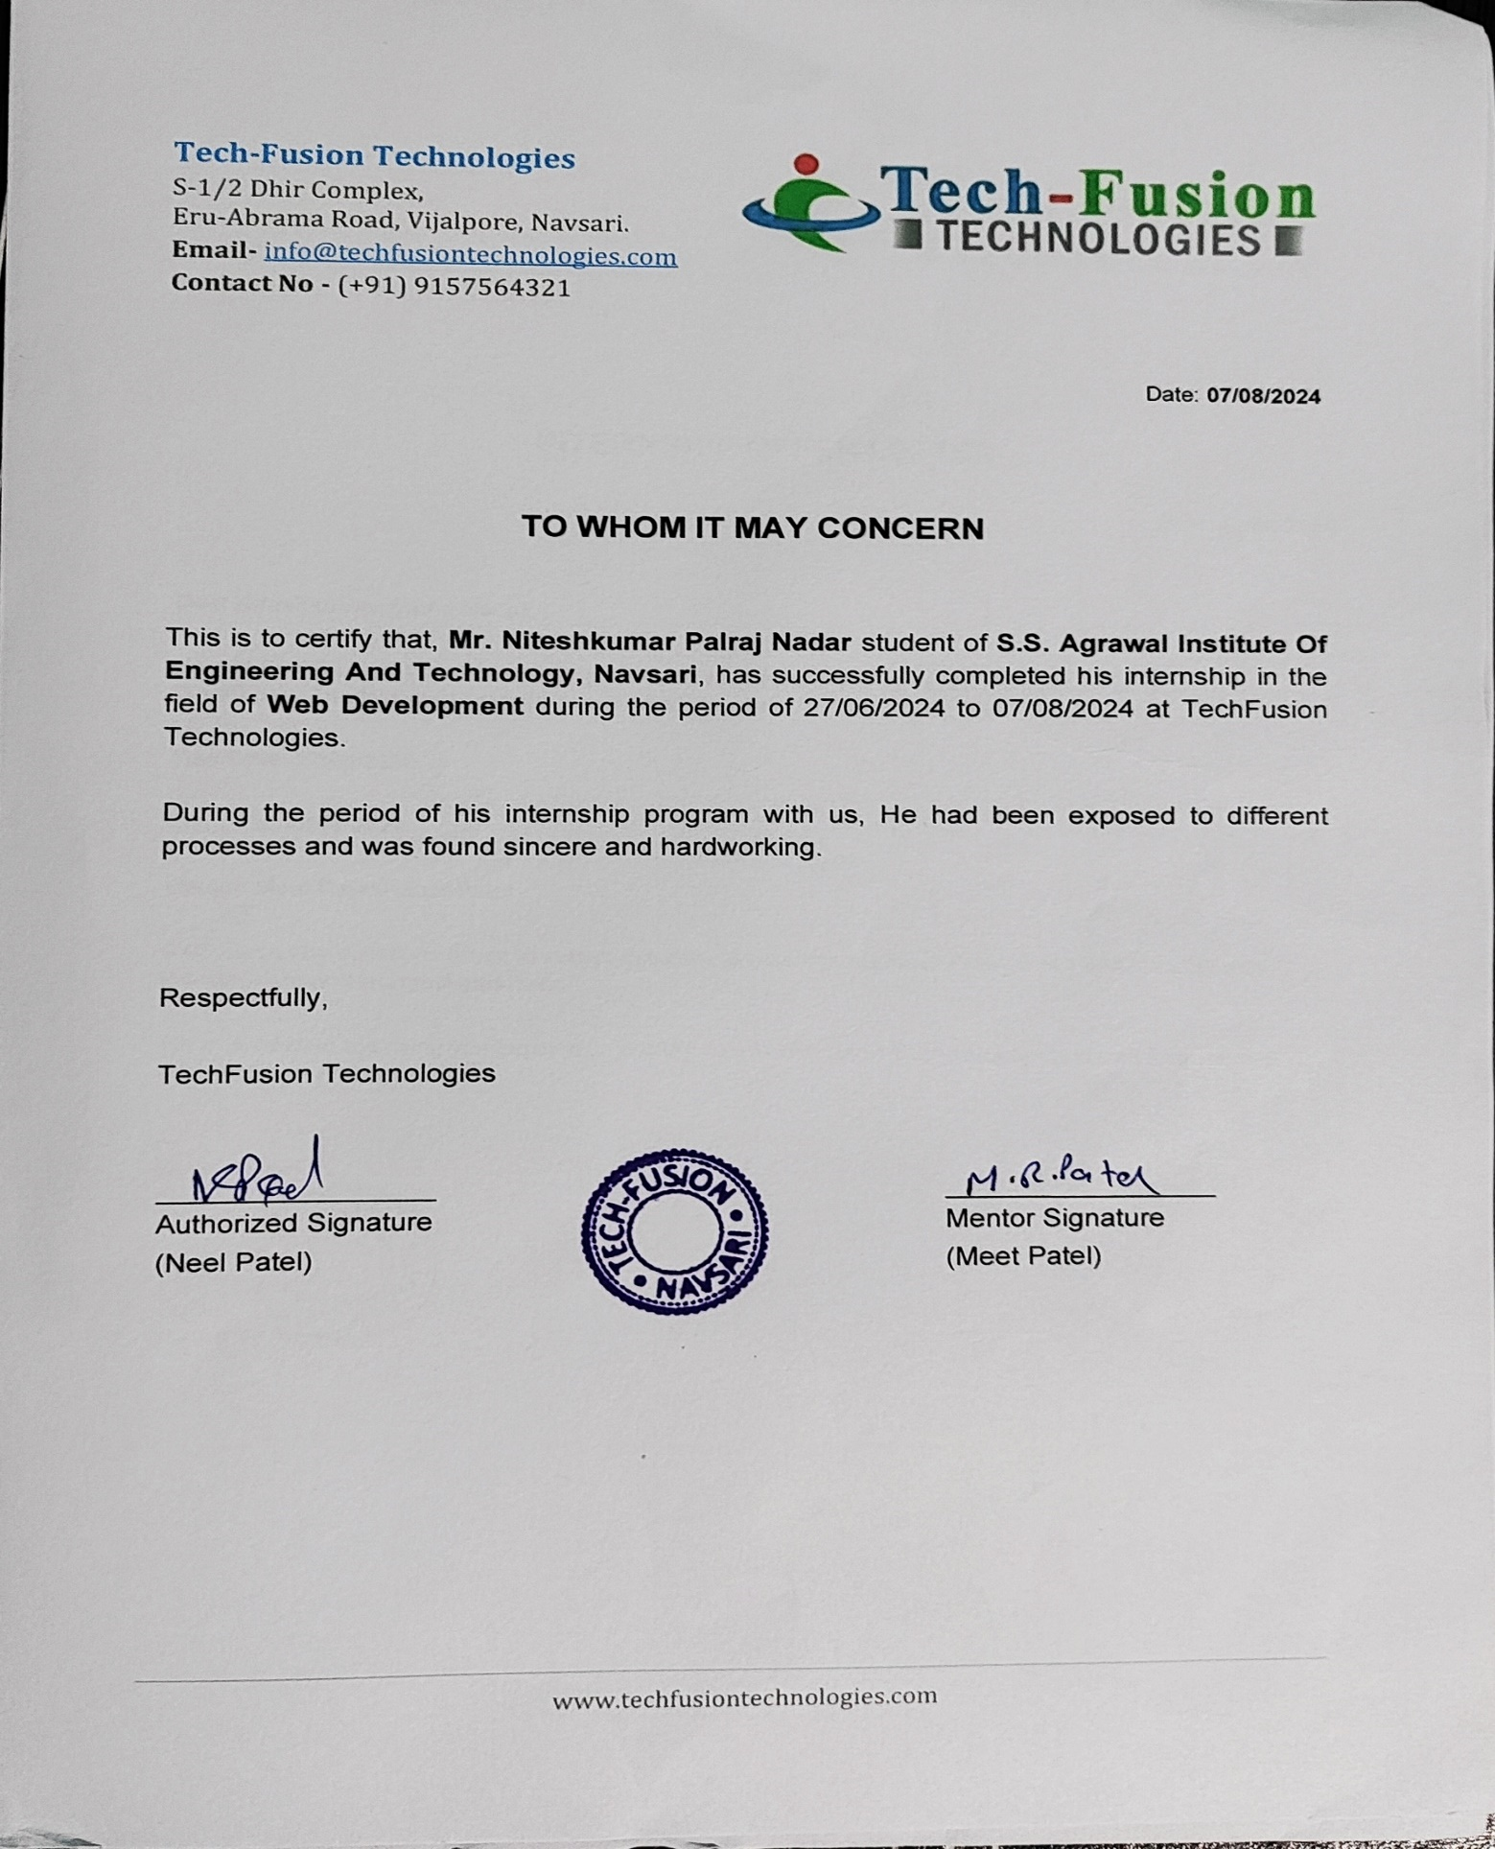

**ACKNOWLEDGEMENT**

I am happy that I have successfully completed my internship but it would be incomplete without the names of the people who have helped me to achieve this milestone, I would like to extend my heartiest thanks with deep sense of gratitude and respect to all those who provide me imminence help and guidance during my internship.

I would like to express my deep sense of gratitude to **Dr. (Prof.) Dipesh Shukla**, **Principal, SSAIET, Navsari,** for his continuous effort in creating a competitive environment in our college and encouraging throughout this course.

I would like to express my sincere thanks to **Prof. Brijesh Bhandari, Head of the Department, SSAIET, Navsari** for his continues encouragement, motivation throughout the internship program.

A special thanks to my mentor during this internship program **Prof. _______________________________, SSAIET, Navsari,** for overall directions, suggestions and encouragement.

I would also like thank the platform that helped me to do the online internship, (Company Name), for their support , availability, and insightful comments and for steering me to the right direction whenever I needed it .

I am grateful to thank all those who I had the pleasure to learn with for with for making this demanding time joyful yet efficient, and for taking the time to answer any of my questions.

Finally I must express my very profound gratitude to my parents for providing me with unfailing support and continuous encouragement throughout my years of study leading to this very moment and particularly for their sacrifices.

**ABSTRACT**

This project is developed on a comprehensive food ordering website for users to enhance their dining experience through a user-centered approach. The website offers an easy-to-use interface for browsing menus, placing personalized orders, and making safe payments. This, as a result, is able to bring simplicity to users in ordering while streamlining operations of food service providers. Key features developed in the website include tracking orders in real time, management of user accounts, and customer support. This system implements the latest technologies in web development to ensure the responsiveness and reliability of the service that could be considered to alleviate some pain points common for online ordering of food. The design of this website concentrates on ease of use, access, and scalability by building grounds for easy enhancement, adapting to emerging market needs.

**LIST OF CONTENT**

|  |  |  |
| --- | --- | --- |
| **Sr. No.** | **Topic** | **Page No.** |
| 1. | Company Profile |  |
| 2. | Project Overview |  |
| 3. | Outcomes |  |
| 4. | Conclusion |  |
| 5. | References |  |

**Company Profile**

**Company Name:** Tech-Fusion Technologies

**Address:** S-1/2 Dhir Complex Opposite Samarpan Sadhak Nivas, Eru-Abrama Road, Vejalpore,Navsari,Gujarat 396445

**Website :** www.techfusiontechnologies.com

**Email :** info@techfusiontechnologies.com

**Phone:** 9157564321

**Project Overview**

* App.py

from flask import Flask,render_template,request,redirect,url_for,flash,session

from flask_mysqldb import MySQL

import os

app = Flask(__name__)

app.secret_key = "food application"

app.config['MYSQL_HOST'] = 'localhost'

app.config['MYSQL_USER'] = 'root'

app.config['MYSQL_PASSWORD'] = ''

app.config['MYSQL_DB'] = 'food'

mysql = MySQL(app)

app.config["UPLOAD_FOLDER"] = 'static/assets/'

@app.route("/")

def index():

cursor = mysql.connection.cursor()

cursor.execute("select * from Product")

data = cursor.fetchall()

cursor.close()

return render_template("index.html",data=list(data))

@app.route("/<cat>")

def category_vise(cat):

cursor = mysql.connection.cursor()

cursor.execute("select * from Product WHERE category = %s",(cat,))

data = cursor.fetchall()

cursor.close()

return render_template("index.html",data=list(data))

@app.route("/cart")

def cart():

if "email" not in session:

flash("Please, login first")

return redirect(url_for("sign_in"))

else:

cursor = mysql.connection.cursor()

cursor.execute("SELECT cart.id,product.photo,product.name,product.price,cart.quantity FROM cart JOIN product ON cart.product_id = product.id WHERE cart.user_id = %s",(session["id"],))

data = cursor.fetchall()

cursor.execute("SELECT SUM(product.price * cart.quantity),(COUNT(product_id) * 50),(SUM(product.price * cart.quantity) + (COUNT(product_id) * 50)) FROM cart JOIN product ON product.id = cart.product_id WHERE user_id = %s",(session["id"],))

cart_det = cursor.fetchone()

cursor.close()

return render_template("cart.html",data=data,cart_det=cart_det)

@app.route("/cart_delete/<int:id>/")

def cart_delete(id):

cursor = mysql.connection.cursor()

cursor.execute("DELETE FROM cart WHERE id = %s",(id,))

mysql.connection.commit()

flash("Removed from cart")

return redirect(url_for("cart"))

@app.route("/food/<int:id>/")

def food_info(id):

if "email" not in session:

flash("Please, login first")

return redirect(url_for("sign_in"))

else:

cursor = mysql.connection.cursor()

cursor.execute("SELECT * FROM product WHERE id = %s",(id,))

data = cursor.fetchone()

return render_template("foodinfo.html",data=data)

@app.route("/add_cart",methods=["GET","POST"])

def add_cart():

data = request.form

cursor = mysql.connection.cursor()

cursor.execute("INSERT INTO cart ( user_id, product_id, quantity) VALUES (%s,%s,%s)",(session["id"],data["pid"],data["quantity"]))

mysql.connection.commit()

flash("Added to cart")

return redirect(url_for("cart"))

@app.route("/cart_edit/<int:id>/")

def cart_edit(id):

cursor = mysql.connection.cursor()

cursor.execute("SELECT cart.id,product.photo,product.name,product.price,cart.quantity,product.description,product.category FROM cart JOIN product ON cart.product_id = product.id WHERE cart.user_id = %s AND cart.id = %s",(session["id"],id))

data = cursor.fetchone()

return render_template("editcart.html",data=data)

@app.route("/edit_cart",methods=["GET","POST"])

def edit_cart():

data = request.form

cursor = mysql.connection.cursor()

cursor.execute("UPDATE cart SET quantity = %s WHERE id = %s",(data["quantity"],data["cid"]))

mysql.connection.commit()

flash("Cart Edited")

return redirect(url_for("cart"))

@app.route("/checkout",methods=["GET","POST"])

def checkout():

if request.method == "GET":

cursor = mysql.connection.cursor()

cursor.execute("SELECT SUM(product.price * cart.quantity),(COUNT(product_id) * 50),(SUM(product.price * cart.quantity) + (COUNT(product_id) * 50)) FROM cart JOIN product ON product.id = cart.product_id WHERE user_id = %s",(session["id"],))

cart_det = cursor.fetchone()

if cart_det[0] == None :

flash("Enable to checkout")

return redirect(url_for("cart"))

else:

return render_template("checkout.html",cart_det=cart_det)

else:

data = request.form

cursor = mysql.connection.cursor()

cursor.execute("SELECT id,product_id,quantity,((SELECT price FROM product WHERE id = product_id) * (quantity)) FROM cart WHERE user_id = %s",(session["id"],))

cartdatas = cursor.fetchall()

for cartdata in cartdatas :

insertquery = "INSERT INTO orders (user_id,product_id,quantity,price,address,city,state,zip_code,country) VALUES (%s,%s,%s,%s,%s,%s,%s,%s,%s)"

cursor.execute(insertquery,(session["id"],cartdata[1],cartdata[2],(cartdata[3] + 50),data["address"],data["city"],data["state"],data["zip"],data["country"]))

cursor.execute("DELETE FROM cart WHERE id = %s ",(cartdata[0],))

mysql.connection.commit()

cursor.close()

return redirect(url_for("orders"))

@app.route("/orders")

def orders():

if "email" not in session:

flash("Please, login first")

return redirect(url_for("sign_in"))

else:

cursor = mysql.connection.cursor()

cursor.execute("SELECT (SELECT photo FROM product WHERE id = product_id),(SELECT name FROM product WHERE id = product_id),price,quantity,status FROM orders WHERE user_id = %s ORDER BY order_date DESC",(session["id"],))

orderdata = cursor.fetchall()

cursor.close()

return render_template("orders.html",orders=orderdata)

@app.route("/sign_in",methods=["GET","POST"])

def sign_in():

if request.method == "GET":

return render_template("signin.html")

else:

data = request.form

cursor = mysql.connection.cursor()

cursor.execute("select email,password,id from users WHERE email = %s",(data["email"],))

record = cursor.fetchone()

cursor.close()

if record :

if data["email"] == record[0] and data["password"] == record[1] :

session["id"] = record[2]

session["email"] = data["email"]

session["password"] = data["password"]

return redirect(url_for("index"))

elif data["email"] == record[0] and data["password"] != record[1]:

flash("Password Wrong")

return redirect(url_for("sign_in"))

else:

flash("Unknown error")

return redirect(url_for("sign_in"))

elif data["email"]=="admin@gmail.com" and data["password"]=="admin@123":

session["admin"] = data["email"]

return redirect(url_for("admin_home"))

else:

flash("Account not found")

return redirect(url_for("sign_in"))

@app.route("/logout")

def logout():

session.pop("email",None)

session.pop("password",None)

return redirect(url_for("sign_in"))

@app.route("/register",methods=["GET","POST"])

def register():

if request.method == "GET":

return render_template("register.html")

else:

data = request.form

cursor = mysql.connection.cursor()

query = "INSERT INTO Users (name, email, phone, password) VALUES (%s,%s,%s,%s)"

cursor.execute(query,(data["name"],data["email"],data["phone"],data["password"]))

mysql.connection.commit()

cursor.close()

flash("Successfully Registered")

return redirect(url_for("sign_in"))

@app.route("/admin_home",methods=["GET","POST"])

def admin_home():

if "admin" in session:

if request.method == "GET":

return render_template("admin_home.html")

else:

data = request.form

photo = request.files["photo"]

photo.save(os.path.join(app.config["UPLOAD_FOLDER"],photo.filename))

cursor = mysql.connection.cursor()

cursor.execute("INSERT INTO Product (name, photo, category, price, description) VALUES (%s,%s,%s,%s,%s);",(data["name"],photo.filename,data["category"],data["price"],data["desc"]))

mysql.connection.commit()

cursor.close()

return redirect(url_for("admin_items"))

else:

flash("Please, sign in as admin")

return redirect(url_for("sign_in"))

@app.route("/admin_items")

def admin_items():

if "admin" in session:

cursor = mysql.connection.cursor()

cursor.execute("select * from Product")

data = cursor.fetchall()

cursor.close()

return render_template("admin_items.html",data=list(data))

else:

flash("Please, sign in as admin")

return redirect(url_for("sign_in"))

@app.route("/delete/<int:id>")

def delete(id):

cursor = mysql.connection.cursor()

cursor.execute("DELETE FROM Product WHERE id = %s",(id,))

mysql.connection.commit()

cursor.close()

return redirect(url_for("admin_items"))

@app.route("/admin_orders")

def admin_orders():

if "admin" in session:

cursor = mysql.connection.cursor()

cursor.execute("SELECT orders.id,product.photo,product.name,orders.quantity,orders.price,orders.address,orders.city,.orders.zip_code,orders.state,orders.country,(SELECT name FROM users WHERE id = user_id),orders.status FROM orders JOIN product WHERE orders.product_id = product.id ORDER BY order_date DESC")

data = cursor.fetchall()

return render_template("admin_orders.html",data=data)

else:

flash("Please, sign in as admin")

return redirect(url_for("sign_in"))

@app.route("/order_update/<int:id>",methods=["GET","POST"])

def order_update(id):

if request.method == "POST":

data = request.form["status"]

cursor = mysql.connection.cursor()

cursor.execute("UPDATE orders SET status = %s WHERE id = %s",(data,id))

mysql.connection.commit()

return redirect(url_for("admin_orders"))

@app.route("/logout_admin")

def logout_admin():

session.pop("admin",None)

return redirect(url_for("sign_in"))

if __name__ == "__main__":

app.run(debug=True,host='0.0.0.0')

**Website Preview**

* **Register Page**

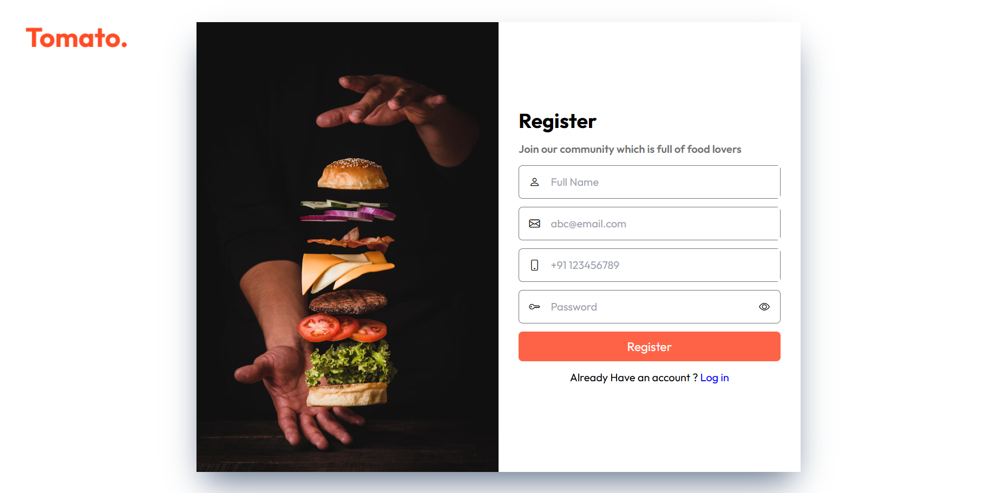

* **Login Page**

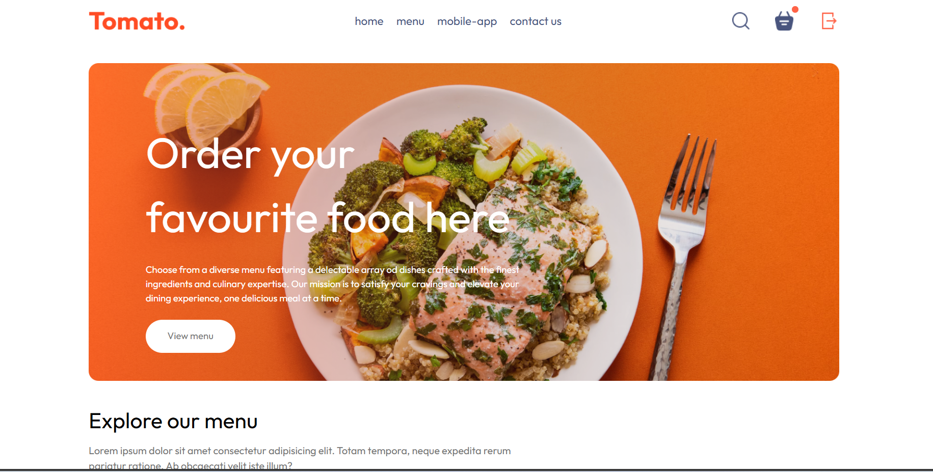

**­**

**Conclusion**

All in all, our project on the website for ordering food has successfully created an easy, user-friendly platform that increases the dining engagement. It provides intuitive navigation to the users, options of secured payments, and tracking of orders in real time, hence catering to a few of the main needs of the users while ensuring some of the main operational efficiencies. Through rigorous testing and user feedback, we have ensured a seamless experience for both customers and food providers. This will have to be continuously updated and improved with the introduction of new features as dictated by changing trends and consumer preferences. All in all, this project will satisfy the demand of today's market and position us for growth and further innovation in food service

**References**

* PYTHON References

Tutorial points: https://www.tutorialspoint.com/flask/index.html